# Team Bravo

(Campbell, Hinkle, Luna, Orozco, Upadhyaya)

**Case Study**: Bacchus Winery

**Assumptions:**

* Shipping of Material occurs monthly or less.
* Salary and hourly wage information is not required for this assignment only the time

**BUSINESS RULES:**

* MATERIAL ORDERS have one SUPPLIER
* SUPPLIER can have many MATERIAL ORDERS
* SUPPLY ORDERS have many MATERIAL
* DISTRIBUTORS have many DISTRIBUTOR ORDERS
* DISTRIBUTOR ORDERS can have many PRODUCTS

**Initial ORD for Distributor Orders:**

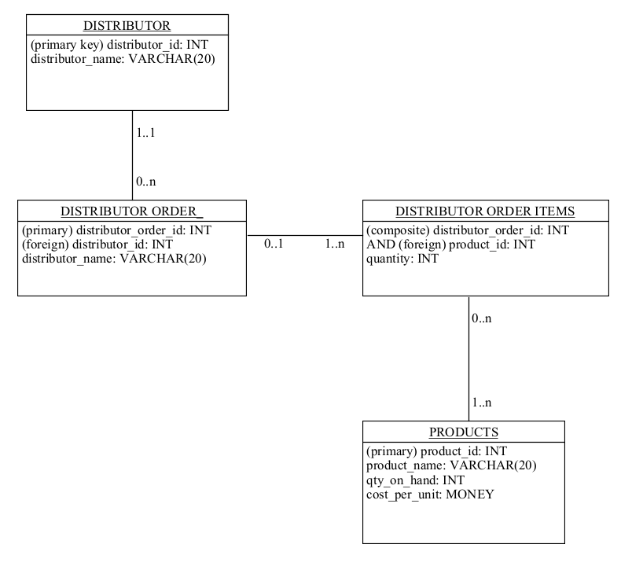

Initial ORD for Supplier Orders:

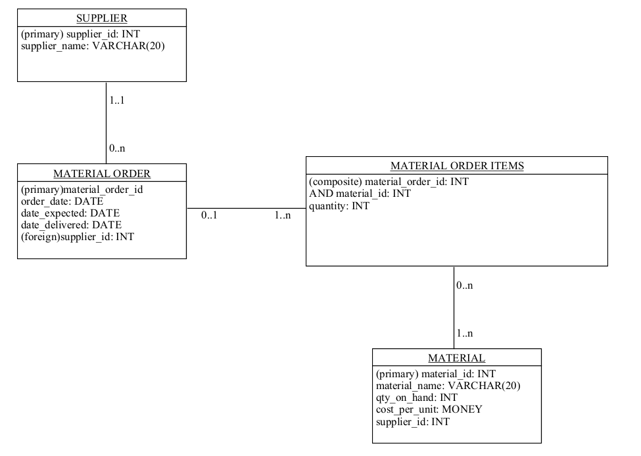

Initial ORD for Employee Payroll:

